In your own words, what was the book about?

Who was the main character? What was he/she like?

Did you like the book? Why was this?

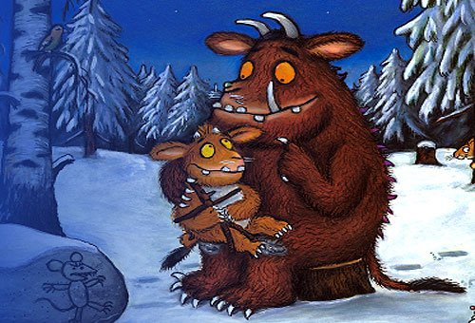

Self Assessment

